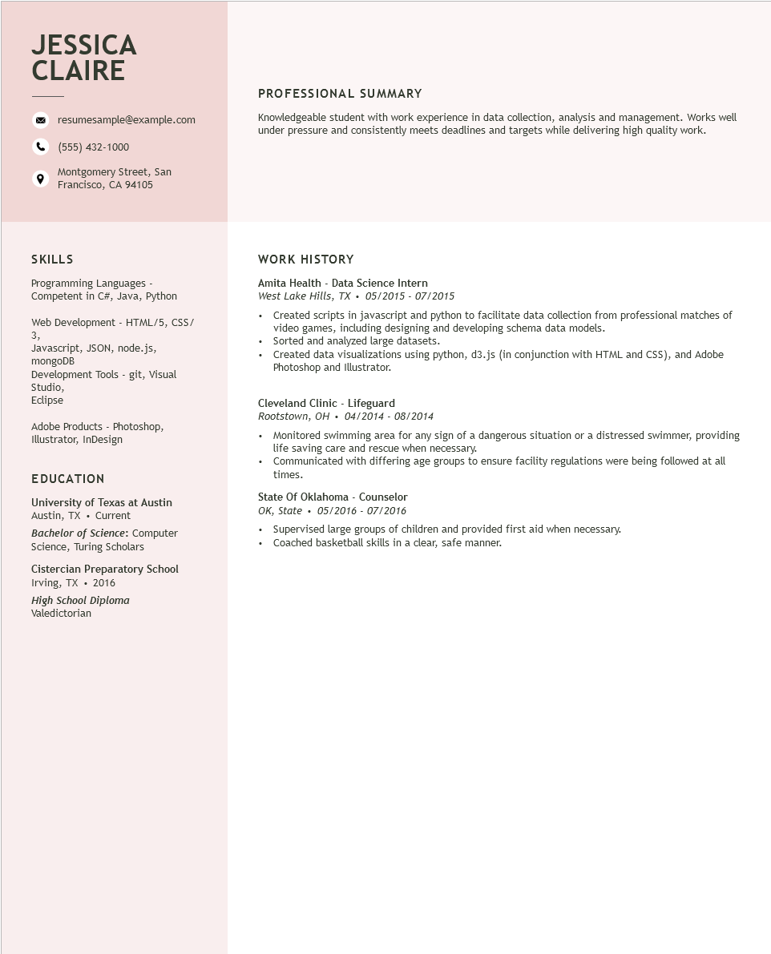
JESSICA CLAIRE
resumesample@example.com
(555) 432-1000
Montgomery Street, San Francisco, CA 94105
PROFESSIONAL SUMMARY
Knowledgeable student with work experience in data collection, analysis and management. Works well under pressure and consistently meets deadlines and targets while delivering high quality work.
SKILLS
Programming Languages - Competent in C#, Java, Python
Web Development - HTML/5, CSS/
3,
Javascript, JSON, node.js,
mongoDB
Development Tools - git, Visual
Studio,
Eclipse
Adobe Products - Photoshop, Illustrator, InDesign
EDUCATION
University of Texas at Austin Austin, TX. Current
Bachelor of Science: Computer Science, Turing Scholars
Cistercian Preparatory School Irving, TX. 2016
High School Diploma
Valedictorian
WORK HISTORY
Amita Health - Data Science Intern
West Lake Hills, TX. 05/2015 07/2015
• Created scripts in javascript and python to facilitate data collection from professional matches of video games, including designing and developing schema data models.
•
Sorted and analyzed large datasets.
•
Created data visualizations using python, d3.js (in conjunction with HTML and CSS), and Adobe Photoshop and Illustrator.
Cleveland Clinic - Lifeguard
Rootstown, OH. 04/2014 - 08/2014
• Monitored swimming area for any sign of a dangerous situation or a distressed swimmer, providing life saving care and rescue when necessary.
• Communicated with differing age groups to ensure facility regulations were being followed at all times.
State of Oklahoma - Counselor
OK, State
05/2016 - 07/2016
Supervised large groups of children and provided first aid when necessary. Coached basketball skills in a clear, safe manner.

